**Project Design Phase-II**

**Data Flow Diagram & User Stories**

| Date | 8 November 2023 |
| --- | --- |
| Team ID | Team-591602 |
| Project Name | FetalAI: USING MACHINE LEARNING TO PREDICT AND MONITOR FETAL HEALTH |
| Maximum Marks | 4 Marks |

**Data Flow Diagrams:**

A Data Flow Diagram (DFD) is a traditional visual representation of the information flows within a system. A neat and clear DFD can depict the right amount of the system requirement graphically. It shows how data enters and leaves the system, what changes the information, and where data is stored.

Example: DFD Level 0 (Industry Standard)

**Example: (Simplified)**

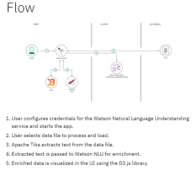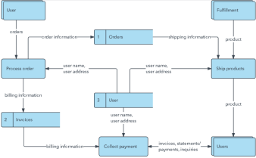

**User Stories**

Use the below template to list all the user stories for the product.

| **User Type** | **Functional**  **Requirement**  **(Epic)** | **User Story Number** | **User Story / Task** | **Acceptance criteria** | **Priority** | **Release** |
| --- | --- | --- | --- | --- | --- | --- |
| Customer  (Mobile user) | Registration | USN-1 | As a mobile user, I can register for the application by entering my email, password, and confirming my password. | * Successfully entering email, password, and confirming password leads to account creation. * Access to the FetalAI dashboard is granted upon successful registration. | High | Sprint-1 |
|  |  | USN-2 | As a mobile user, I will receive a confirmation email once I have registered for the FetalAI application. | * Receive a confirmation email after successful registration. * The confirmation email should contain a clickable link to confirm the registration. | High | Sprint-1 |
|  |  | USN-3 | As a mobile user, I can register for the FetalAI application through smartbridge internz platform. | Successful registration and access to the FetalAI dashboard using smartbridge internz credentials. | Low | Sprint-2 |
|  |  | USN-4 | As a user, I can register for the application through Gmail | Successful registration and access to the FetalAI dashboard through Gmail. | Medium | Sprint-1 |
|  | Login | USN-5 | As a mobile user, I can log into the FetalAI application by entering my email and password. | Successfully entering a valid email and password leads to login. | High | Sprint-1 |
|  | Dashboard | USN-6 | As a user of the FetalAI application, I want to view all the details related to the health predictions of the selected pregnancies. | * Access to a dashboard displaying comprehensive details about the health predictions of selected pregnancies. * The dashboard should provide insights such as predicted health parameters, recommendations, and relevant data visualizations | High | Sprint-1 |
|  |  | USN-7 | As a user of the FetalAI application, I want to filter and sort the predictions based on various criteria | * Ability to filter and sort predictions based on parameters such as gestational age, health risk levels, and other relevant factors. * The FetalAI dashboard should provide a user-friendly interface for seamless navigation and data exploration. | High | Sprint-2 |
| Customer (Web user) |  | USN-8 |  |  |  |  |
| Customer Care Executive |  |  |  |  |  |  |
| Administrator |  |  |  |  |  |  |
|  |  |  |  |  |  |  |
|  |  |  |  |  |  |  |
|  |  |  |  |  |  |  |